# Tutorial 1: Simple Reproduction, or how a capitalist economy works

©Alan Freeman 2018

# Where to begin

This tutorial is distributed with the [Capitalism App.](https://github.com/axfreeman/capitalism-9.0) It takes you through an illustration, due to Marx, of the way capitalism works. It assumes you have read the [User Guide](https://github.com/axfreeman/capitalism-9.0/blob/master/User%20Guide.pdf) which explains terms like ‘action button’ that are scattered through this text. The screen is fairly self-explanatory, so you may get by without it. If not, [RTFM](https://en.wikipedia.org/wiki/RTFM).

Here’s where it all begins.

* Find the file ‘capitalism.exe’ and run it.
* Click on the ‘Exchange’ action button

Look at top table, shown in Figure 1. The columns may not look exactly the same, but you can drag them into the shape and size of your choosing.

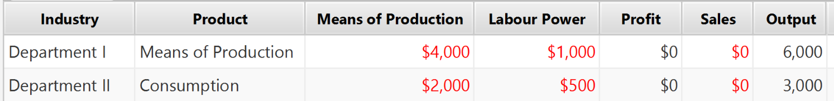

Figure 1 Simple Reproduction, after Exchange and before Production

The project you are running is one of a list that you can access from the *project selection* box (see the User Guide). It’s called ‘Simple Reproduction’. There are more Simple Reproduction projects in the list, and we will deal with them later in this tutorial. This is the simplest of them.

Simple Reproduction demonstrates why a capitalist economy is possible at all. How is it that we buy everything we need in the market, without knowing where it came from or anything much about it, that we go to work without knowing who is buying our stuff, yet at the end of each year and each day, what we need is ready and waiting for us? Conversely, why does this only work some of the time? What causes Reproduction to break down, causing a crisis?

There are many theories which attempt to explain both why the capitalist market sometimes works, and why it sometimes doesn’t. The App is a way of checking out how any such theory works. Mathematically it provides ‘existence theorems’ for the theories.

Simple Reproduction is a ‘mother’ theory: all explanations of capitalism spring from it.

* It is the foundation of modern Macroeconomics. If you want to understand the ‘circular flow of income’ on which the National Accounts are based, or the ‘Input-output analysis’ developed by the Russian-born economist Wassily Leontieff in the 1930s which underpins most modern National Accounting systems, or (if you are a glutton for punishment) the complicated equation systems known as ‘Linear Production Systems’ associated with the Italian economist Piero Sraffa – start here.
* It makes the fewest special assumptions. All more complicated systems – for example if capital accumulates, if there is technical change, if prices diverge from values – are all special cases of this basic, abstract system. This includes systems with many inputs and many outputs, systems with production functions, with complex financial operations or forms of money, and so on. Any economy which produces commodities must satisfy certain basic laws, just as any system of moving bodies has to satisfy Newton’s three laws of motion. If you want to move from the abstract to the concrete, this is for you.

To sum up, it is historically, and logically, the best place to start trying to understand the economies of our time.

If you are familiar with Marx’s notation, you will recognise the rows and columns in the table he provides (see [page 243 of the CyberMarx online edition](https://www.marxists.org/archive/marx/works/download/pdf/Capital-Volume-II.pdf)), shown in Figure 2. Marx’s ‘[Department] I’ is called ‘Means of Production’ in the ‘Producer’ column and Marx’s [II] is called ‘Consumption’

🏱Note two phrases: “exclusive of the fixed capital”, and ‘The figures may indicate millions of marks, francs, or pounds sterling”. They are important, and we will return to them.

|  |
| --- |
|  |

Figure 2 Marx's table representing Simple Reproduction

## When do things happen? How a simulation helps

A simulation, unlike a diagram or a printed page, is ‘live’ – as the programme proceeds, the numbers change. That’s why, in Figure 1, there is no profit and no sales inventory. It’s because we have only reached the ‘exchange’ stage, and nothing has been produced. Similarly, in Figure 3 the workers own no labour power. That’s because they have just sold it to the capitalists, where it can be found in the fourth column of Figure 1.

In the production stage, the sales inventory will rise to $3000 in Department II and $6,000 in Department I, and the inputs of these departments will vanish. In parallel, workers will consume what they have bought and replenish their labour power. The simulation lets you follow these changes as they happen, blow by blow.

it does more: it *tests* economic theories. If a theory is inconsistent, or its assumptions lead to unexpected conclusions, it will show up when we try to simulate it.

This differentiates the *temporal* method underling the App from the ‘equilibrium’ theories that dominate economic theory today (including, unfortunately, most Marxist theory), which all start by assuming the market is perfect: at the end of a cycle of production and exchange, everything is sold and nothing changes. Of course, this is not what happens in reality – only in the complicated mathematical equations. This is a flaw in the mathematical methods used; they don’t oblige the economists who use them to keep track of the actual transactions in the economy. A simulation, to the contrary, insists that every transaction must be accounted for, and if it’s not, the failure will show.

# What’s going on? Understanding the tables

The main point of this tutorial is to get you using the App as quickly as possible. I’m therefore going to keep the definitions to the absolute minimum needed to get you going. What follows isn’t, therefore, an introduction to economic theory; it’s an introduction to the App.

The App recognises two distinct types of owner: **social classes**, and **industries**. Industries, and social classes, both make, and consume, useful things that are bought and sold, called **commodities**.

The industries are what you see in the columns of both Figure 1 and Figure 2. Social classes are shown underneath, as shown in Figure 3. Commodities are shown at the bottom of the table as shown in Figure 1

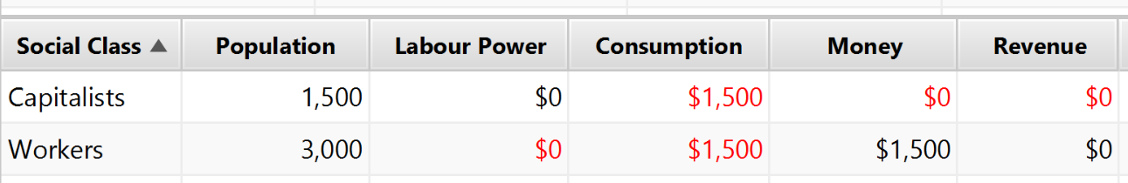

Figure 3 Social Classes

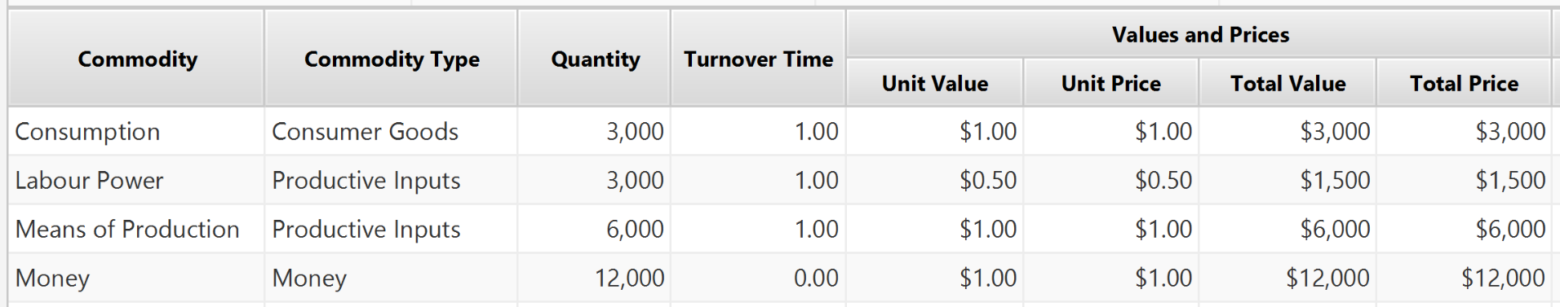Figure 4 Commodities

## What is an industry?

Underlying all economic theories, we find some concept of private property, on which a capitalist economy depends. This sounds simple enough, and by and large it is, but it has profound consequences, which account for many aspects of the simulation. First off, the term ‘private’ can be confusing, because it tends to imply that owners are individual humans. Actually, most owners are corporate entities, known in legal parlance as ‘legal persons’.

An industry is a collection of legal persons that produces a particular type of commodity. Industry I produces commodities that are used to make other commodities, such as iron or steel. Industry II produces commodities that are consumed by social classes, such as bread.

Industries can be subdivided: we may study flour-making separately from baking, or we may study both together and call them the ‘bread industry’. Neither way of doing things changes the basics, because the numbers add up: the bread industry’s profit is equal to the combined profit of milling, and baking. Hence, the arithmetic relations between I and II stay valid if we take the millers out of II and put them in I; it’s just that I becomes bigger. It’s only a question of where we draw the line.

Industries may produce more than one commodity. There is a big literature about this and the App can be extended to cover it. Right now, don’t bother. In the App, one industry produces one commodity – but several industries can produce the same commodity.

Industries also consume; bread-making consumes flour, yeast, ovens and energy, for example. So, what do the columns in Figure 1 and Figure 2 tell us? They show what each industry needs to consume, in order to make its product. Department I consumes $4000 worth of flour, ovens and energy (‘Means of Production’) and produces an output worth $6,000. Department II consumes $2,000 worth of ‘Means of Production’ and produces an output worth $3000.

## What is a social class?

Industries also consume inputs that are supplied, not by other industries, but by social classes. They also pay money to social classes. Economic theories differ as to the reasons for these payments, and the App will be developed to illustrate these differences. All theories agree, however, that all industries employ workers, and pay them a wage. This means they sell a commodity, their labour or, as Marx puts it, their ‘labour power’. An industry pays its workers money in proportion to the amount of work it gets from them and in return is entitled

* To make the workers produce
* To keep the product

As a result, the industry makes profits, which are the difference between the sale price of the product and the cost of all the inputs including labour power. These profits are transferred to the owners. Profits, like wages, are a *revenue* – a stream of income that the receiver is entitled to. The entitlement is a result of their *property rights*; capitalists are entitled to the profits from an industry if they own it, or a share in it. Workers are entitled to wages because they own their own persons. Other revenues are, for example, rent which accrues to landowners, interest which accrues to money owners, and taxes which accrues to governments.

This leads to our definition of social class: it is a collection of legal persons who are entitled to a particular kind of revenue, by virtue of their property.

Box 1: what do we mean by a quantity of commodities?

**How much?**

Marx’s numbers are all money quantities. For this reason, they ‘add up’; Department I makes $6,000 and Department II makes $3,000, so total output is $9,000.

It’s not always meaningful to add up quantities. While it is perfectly reasonable to say ten loaves of bread are twice as many as five, two ovens plus three loaves of bread don’t make five of anything. Thus, we can and do speak of ‘quantities’ of a single commodity or ‘use value’ as Marx terms it, but the App will not add up unlike or ‘heterogeneous’ magnitudes.

You will see a dash instead of a number, whenever there is a table entry which suggests unlike things are being added up.

Of course, classes can have mixed sources of revenue: typically for example a farmer or small businessperson will work in a business and also get profit from it. The App allows for this, but at this point we are studying the simplest possible case, in which all wage-earners are in one class (‘Workers’) and all property-owners are in another (‘Capitalists’). Figure 3 displays the property, and revenue, of these two classes.

## What is a commodity?

A commodity, strictly speaking, is a useful thing produced for sale by labour. Theories sometimes differ about what they treat as a commodity. The App adopts the widest possible definition and anything that is bought and sold – for example, real estate – is allowed. This isn’t because the strict definition is unimportant, but because the App has to allow as many theories as possible to be tested.

That’s it with the definitions. Let’s move on to the action.

## Producing

The